Have you ever wanted to go back and find a previous instant messaging (IM) conversation that contains a URL you’re looking for? Or see the history of your instant messages and calls? Skype lets you do this using conversation history.

Verify that your conversation history is being saved

1. In the Skype main window, click the **Options** Screenshot of Lync Options button  button, and then click **Personal**.
2. In the Personal information manager section, look for a check box labeled **Save IM conversations in my email Conversation History folder**.

* If the check box is there and operable but clear, conversation history is available but not turned on. To turn it on, select this check box.
* If the check box is there and selected, your conversation history is being saved.

Turn off Conversation History  
  
If you don’t want to save your conversation history, clear the **Save IM conversations in my email Conversation History folder** check box, and then click **OK**.

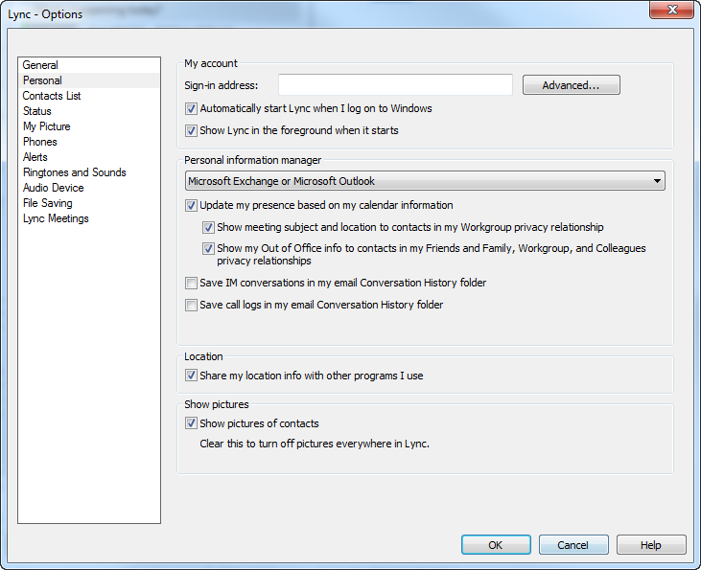

**Look at your conversation history in Skype**So, if your conversation history is available, in the Skype main window, click the **Conversations** tab.

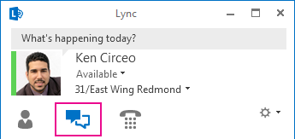

***Skype Conversations are saved for 90 Days in the Conversation History folder in Outlook. To save a specific conversation for longer than 90 days, you can either move it to a different Inbox folder or select a message and save it to OneNote.***

Your conversations are shown with the most recent at the top. Calls you’ve had are also shown in the **Conversations** list. In addition to the **ALL** selection, you can click one of the other two tabs on the Conversations window:

* **MISSED**   Lists only your missed conversations and calls
* **CALLS**   Lists only your Skype calls (completed and missed) ***NOTE: phone conversations are not recorded. Only the phone number, date and time is captured.***

There’s a selection at the bottom of the window called **View More in Outlook** that you can use if you use Outlook. Choosing it gives you a complete history. You can delete any conversation (maybe it’s been around long enough) by right-clicking it, and selecting **Delete**.

**Manage previous Skype conversations from Outlook**

If you use Outlook, your Skype conversations are saved there, too, in the Conversation History folder. From this folder, you can:

* Find all conversations with a certain person by typing their name in the search box
* Find all conversations that include a certain keyword by typing the term in the search box
* Email a conversation by clicking it and then, in the Respond group of the Home tab, using the appropriate option

**Find a past conversation with a contact**

1. Open Skype, and in your Contacts list, right-click the contact whose previous conversation you want to view. Or, you can enter the name in the search box.
2. Choose **Find Previous Conversations**.

You’ll now see a listing of the contact’s conversations with you in the Outlook **Conversation History** folder. To track down a specific conversation, browse to the approximate date of the conversation. Or, type in a term that might have come up in the conversation in the search box at top of the Outlook window.